Modeling the impact of whole blood pathogen inactivation on transfusion-related adverse events and healthcare spending in Ghana

W. Alton Russell1,2, Shirley Owusu-Ofori3, Alex Owusu-Ofori3,4, Eileen Micah3, Betty Norman3,4, Brian Custer3,4

1Department of Management Science and Engineering, Stanford University Stanford, CA 2Blood Systems Research Institute, San Francisco, CA 3Department of Medicine, Komfo-Anokye Teaching Hospital, Kumasi, Ghana 4Kwame Nkrumah University of Science and Technology, Kumasi, Ghana 5Department of Laboratory Medicine, University of California, San Francisco, CA

**Corresponding author:** W. Alton Russell, Management Science and Engineering, Stanford University, Stanford CA 94305. email: [altonr@stanford.edu](mailto:altonr@stanford.edu).

**Alt. author contact:** Brian Custer, [bcuster@vitalant.org](mailto:bcuster@vitalant.org)

**Key words:** Pathogen inactivation, blood safety, health-economic modeling

**Running title:** Pathogen inactivation in Ghana

**Summary of main point:** 40 words

##### 

# Abstract

**Background:** Despite the promise of pathogen inactivation for reducing transfusion-related adverse outcomes in sub-Saharan Africa, no health-economic assessment is publicly available for any jurisdiction in this region.

**Methods:** We modeled the impact of the Mirasol PI system for whole blood pathogen inactivation in Ghana, estimating the reduction in transfusion-related adverse outcomes and the net impact on healthcare spending. We used micro-costing to estimate the healthcare costs for acute adverse outcomes (bacterial sepsis, malaria, syphilis, and febrile non-hemolytic transfusion reactions [FNHTRs]) and chronic viral infections (HIV, HBV, and HCV), for which we developed disease-specific Markov models with a lifetime horizon and a 3% annual discounting rate.

**Results:** We estimated that implementing Mirasol whole blood nationwide in Ghana would prevent 19,000 to 38,000 transfusion-related outcomes events a year, including XX - YY sepsis cases. While implementing PI would cost an estimated $6.5 to $9.7 million annually, it would avert $7.3 to 23.7 million in healthcare spending on transfusion-related adverse outcomes, yielding an estimated annual net savings of $5.6 million (95% CI -$700 thousand to $15.5 million). In probabilistic sensitivity analysis, PI was net saving in 94.8% of iterations. The conclusion that PI would be cost saving in Ghana was not sensitive to any single parameter for the ranges used in one-way deterministic sensitivity analysis.

**Conclusions:**

##### 

# Introduction

Pathogen inactivation (PI) has been described as a promising new technology for reducing transfusion-transmitted infections (TTIs) and non-infectious transfusion-related adverse outcomes in Sub-Saharan Africa [Ware2018]. PI uses UV light, often in combination with an additive, to inactivate pathogens in blood components or whole blood [1]. The health-economic consequences of PI of plasma and platelet components have been estimated for different health systems, including Poland and Canada [2,3]. Compared to the European and North American settings where prior analyses of PI have focused, health systems in sub-Saharan Africa often experience greater resource constraints, greater baseline rates of certain transfusion-related adverse outcomes, and more frequent blood shortages [4,5]. Furthermore, the common practice of transfusion whole blood rather than derived products limits the applicability of platelet and plasma PI [6]. Whole blood PI may be a more appropriate technology for this region, and a recent randomized trial has analyzed the effectiveness of whole blood PI for averting TT-malaria in Ghana [7]. However, no health-economic assessment has been published for whole blood PI. We developed a decision-analytic model to estimate how the addition of whole blood PI to the existing blood safety program in Ghana would impact the number of transfusion-related adverse outcomes and total healthcare expenditures.

# Methods

We developed a decision analytic to estimate the health-economic consequences of pathogen inactivation in Ghana from a healthcare payer perspective. We considered seven adverse outcomes, including viral TTIs (HIV, HCV, HBV), bacterial TTIs (syphilis, bacterial sepsis), malaria, and febrile non-hemolytic transfusion reactions (FNHTRs), a non-infectious adverse outcome. We estimated the cost per adverse outcome averted and the budget impact of whole blood PI, and we assessed uncertainty through deterministic and probabilistic sensitivity analysis.

## Risk reduction model structure

Our two-armed decision tree compared the costs and consequences of status quo blood safety interventions to those of the status quo plus whole blood PI. The status quo was to test all donations using HIV-Ab, HIV-Ag, HBsAg, Anti-HCV Ab, and syphilis serologic tests [8]. All parameters values and their sources are shown in *Table S1* [7–16], and precise mathematical expressions for all model calculations are provided in the supplement. For each input parameter, we estimated a range of likely values for deterministic sensitivity analysis and assigned a distribution for probabilistic sensitivity analysis.

The per-donation cost of PI, shown in Table 1, was provided by the manufacturer Terumo BCT. We assumed that each whole blood donation would be transfused to a single recipient, and we assumed that if one recipient experienced multiple adverse outcomes from a single transfusion then any adverse outcome costs would be additive. For each of the six TTIs, the baseline (without PI) number of clinically meaningful adverse outcomes was calculated from the annual number of whole blood donations collected nationally, the percent of collected donations not transfused (wastage), the estimated residual risk among donors after TTI screening, and the risk of symptomatic outcome (i.e., likelihood that transfusion of an infectious unit results in a clinically relevant infection). For FNHTR, a non-infectious adverse outcome, the baseline rate of clinically meaningful adverse outcomes per recipient was extrapolated from local data and prior studies, and the per-donation risk of FNHTR was derived by multiplying the per-recipient rate by the estimated average number of whole blood units transfused per recipient. For each adverse outcome, we applied a risk-reduction multiplier for each adverse outcome due to whole blood PI to estimate the number of adverse outcomes prevented by whole blood PI. These multipliers were based on clinical trials where available (malaria, FNHTR) and were based on prior modeling studies otherwise.

## Cost of adverse outcomes

The average cost of each adverse outcome was estimated using a micro-costing approach based on local costs from the Komfo-Anokye Teaching Hospital (KATH) and other healthcare settings. We considered FNHTR, malaria, syphilis, and sepsis as acute adverse outcomes, and we included costs incurred within a year of transfusion (Table 2). For the three chronic TTIs (HIV, HBV, and HCV), we developed Markov models to estimate lifetime healthcare costs, discounting future costs at 3% annually and using the cycle tree method to correct for discretization error (Figure 1) [10]. Costs for each state were comprised of clinic visits, medications, tests, and procedures (Table S1). For all three chronic viruses, we included an annual probability of antiviral treatment initiation at different disease stages. Authors with local clinical expertise estimated these parameter values and uncertainty ranges for these parameters, which we further assessed using scenario analysis. For each chronic virus, we ran the Markov cohort model for a pediatric cohort, age 5 at transfusion, and an adult cohort, age 40 at transfusion [8], and the average cost was derived by assuming 19% of transfusion recipients were pediatric based on an analysis of transfusion recipients in Zimbabwe [12]. Death from other causes was possible from all disease states, and age-specific background mortality was derived from the 2016 age-specific death rate indicator in the World Health Organization Global Health Observatory data repository [11].

For the HIV model, we derived the annual cost of HIV patients on ART by year since ART initiation from a recent empirical study in Ghana [13]. That study found that healthcare costs for ART patients varied depending on time since ART initiation but did not vary significantly based on pre-ART CD4 count. Additionally, the study did not find a strong relationship between pre-ART healthcare costs and CD4 count. We therefore assumed that healthcare costs were the same for patients not on ART regardless of HIV progression and that costs on ART depended only on time since ART initiation. We assumed that HIV patients on ART were not at risk of HIV- or AIDS-related mortality, and that HIV patients not on ART would progress to AIDS at a constant annual probability as early as three years from infection. We assumed a constant annual probability of death from HIV beginning three years after infection and a constant annual probability of death from AIDS. These probabilities were calibrated to a longitudinal study of HIV patients without ART from Uganda [14], and the calibration plots are shown in Figure S1.

States and transitions for the HBV and HCV Markov models were adapted from recent health-economic analyses for the Gambia and for South Africa [15,16]. HCV patients with chronic HCV or with compensated cirrhosis were assigned a probability of treatment with sofosbuvir-ledipasvir or sofosbuvir-daclatasvir, which would cure their infection if successful. We assigned a probability of treatment with tenofovir disoproxil fumarate (tenofovir DF) to HBV patients in the immune reactive or chronic HBeAg-negative states, and we assigned a probability of treatment with tenofovir DF, tenofovir alafenamide, entecavir, or PEG interferon to HBV patients in the compensated or decompensated cirrhosis states. We assumed all patients remain in treatment after initiation and that treatment prevented progression to higher stages of cirrhosis. We assumed a smaller risk of hepatocellular carcinoma remained for patients on treatment with compensated or decompensated cirrhosis.

# Results

1

# Discussion

Our analysis assumed that patients received medical care for all symptomatic adverse outcomes. If this is not true for a significant proportion of patients then we may have overestimated the reduction in healthcare spending on transfusion recipients conferred by PI. However, whole-blood PI confers additional benefits not captured by our analysis. PI can reduce the risk of adverse outcomes besides the six we analyzed, including some emerging infectious diseases before they are identified as blood safety threats. Additionally, our analysis did not consider the non-medical costs, such as productivity loss, transportation, and family caregiver time, and we did not consider the burden of secondary infection from transfusion recipients to others for viruses like HIV and syphilis. Finally, we assumed that all whole blood donations were transfused to a single recipient, but a small fraction of donations (16.6% in 2013 [8]) are fractionated into multiple components which, if infectious, could lead to adverse outcomes in multiple recipients.

##### 

# Declarations

**Funding:** This work was supported by Terumo BCT.

**Conflicts:** WAR received consulting fees from Terump BCT related to this analysis. BC … .

**Ethics/Consent:** This analysis was based on public data and was exempt from institutional ethics review.

**Data and materials:** All data and materials have been uploaded to a public repository.

**Code availability:** All code has been uploaded to a public repository.

**Authors’ contributions:**

##### 

# References

1. Prowse CV. Component pathogen inactivation: A critical review. *Vox Sanguinis*. 2013;104(3):183-199. doi:[10.1111/j.1423-0410.2012.01662.x](https://doi.org/10.1111/j.1423-0410.2012.01662.x)

2. Custer B, Agapova M, Martinez RH. The cost-effectiveness of pathogen reduction technology as assessed using a multiple risk reduction model. *Transfusion*. 2010;50(11):2461-2473. doi:[10.1111/j.1537-2995.2010.02704.x](https://doi.org/10.1111/j.1537-2995.2010.02704.x)

3. Agapova M, Lachert E, Brojer E, Letowska M, Grabarczyk P, Custer B. Introducing pathogen reduction technology in Poland: A cost-utility analysis. *Transfus Med Hemother*. 2015;42:158-165. doi:[10.1159/000371664](https://doi.org/10.1159/000371664)

4. Bloch EM, Vermeulen M, Murphy E. Blood Transfusion Safety in Africa: A Literature Review of Infectious Disease and Organizational Challenges. *Transfusion Medicine Reviews*. 2012;26(2):164-180. doi:[10.1016/j.tmrv.2011.07.006](https://doi.org/10.1016/j.tmrv.2011.07.006)

5. Barro L, Drew VJ, Poda GG, et al. Blood transfusion in sub-Saharan Africa: understanding the missing gap and responding to present and future challenges. *Vox Sanguinis*. 2018;113(8):726-736. doi:[10.1111/vox.12705](https://doi.org/10.1111/vox.12705)

6. Allain JP, Goodrich R. Pathogen reduction of whole blood: utility and feasibility. 2017;27:320-326. doi:[10.1111/tme.12456](https://doi.org/10.1111/tme.12456)

7. Allain JP, Owusu-Ofori AK, Assennato SM, Marschner S, Goodrich RP, Owusu-Ofori S. Effect of Plasmodium inactivation in whole blood on the incidence of blood transfusion-transmitted malaria in endemic regions: The African Investigation of the Mirasol System (AIMS) randomised controlled trial. *The Lancet*. 2016;387(10029):1753-1761. doi:[10.1016/S0140-6736(16)00581-X](https://doi.org/10.1016/S0140-6736(16)00581-X)

8. World Health Organisation. *Global Status Report on Blood Safety and Availability*.; 2017:1-73. <http://apps.who.int/iris/bitstream/handle/10665/254987/9789241565431-eng.pdf?sequence=1>.

9. Osei EN, Odoi AT, Owusu-Ofori S, Allain J-P. Appropriateness of blood product transfusion in the Obstetrics and Gynaecology (O&G) department of a tertiary hospital in West Africa. *Transfusion Medicine*. 2013;23(3):160-166. doi:[10.1111/tme.12028](https://doi.org/10.1111/tme.12028)

10. Jayaraman S, Chalabi Z, Perel P, Guerriero C, Roberts I. The risk of transfusion-transmitted infections in sub-Saharan Africa. *Transfusion*. 2010;50(2):433-442. doi:[10.1111/j.1537-2995.2009.002402.x](https://doi.org/10.1111/j.1537-2995.2009.002402.x)

11. Adjei AA, Kuma GK, Tettey Y, et al. Bacterial contamination of blood and blood components in three major blood transfusion centers, Accra, Ghana. *Japanese Journal of Infectious Diseases*. 2009;62(4):265-269.

12. Owusu-Ofori AK, Owusu-Ofori SP, Bates I. Detection of adverse events of transfusion in a teaching hospital in Ghana. *Transfusion Medicine*. 2017;27(3):175-180. doi:[10.1111/tme.12392](https://doi.org/10.1111/tme.12392)

13. Jimenez-Marco T, Garcia-Recio M, Girona-Llobera E. Our experience in riboflavin and ultraviolet light pathogen reduction technology for platelets: from platelet production to patient care. *Transfusion*. 2018;(July):1-9. doi:[10.1111/trf.14797](https://doi.org/10.1111/trf.14797)

14. Sluis J van der, Kate F ten, Vuzevski V, Kothe F, Aelbers G, Eijk R van. Transfusion syphilis, survival of Treponema pallidum in stored donor blood. *Vox Sanguinis*. 1985;49(6):390-399. doi:[10.1111/j.1423-0410.1985.tb01131.x](https://doi.org/10.1111/j.1423-0410.1985.tb01131.x)

15. Adegoke AO, Akanni OE. Survival of treponema pallidum in banked blood for prevention of syphilis transmission. *North American Journal of Medical Sciences*. 2011;3(7):329-332. doi:[10.4297/najms.2011.3329](https://doi.org/10.4297/najms.2011.3329)

16. Owusu-Ofori AK, Parry CM, Bares I. Transfusion-transmitted syphilis in teaching hospital, Ghana. *Emerging Infectious Diseases*. 2011;17(11):2080-2082. doi:[10.3201/eid1711.110282](https://doi.org/10.3201/eid1711.110282)

##### 

**Table 1** Parameters for modeling the risk of adverse outcomes with and without whole blood pathogen inactivation

| **Risk model parameters** | **Value (range); distribution** | **Source** |
| --- | --- | --- |
| System parameters | | |
| Percent recipients who are pediatric | 19% (15%–25%); PERT | # |
| Number of components transfused | 160295 (128236–192354); PERT | # |
| Percent of donations not transfused | 9% (1%–17%); PERT | A |
| Cost of PRT per treatment (in $) | $46 ($37–$55); PERT | B |
| Baseline risk | | |
| HIV | 0.112% (0.036%–0.324%); PERT | # |
| Sepsis | 13% (7.56%–18.6%); Beta(24, 168) | # |
| HCV | 0.54% (0.135%–1.22%); PERT | # |
| HBV | 0.94% (0.235%–2.12%); PERT | # |
| Syphilis | 0.064% (0.034%–0.092%); PERT | C |
| Malaria | 25% (19.8%–30.2%); Beta(91, 276) | # |
| FNHTR | 3.17% (1.6%–5.98%); Beta(26, 406) | # |
| Symptomatic outcome risk | | |
| HIV | 98.3% (50%–100%); PERT | # |
| Sepsis | 50% (30%–70%); PERT | # |
| HCV | 100% (50%–100%); PERT | # |
| HBV | 55.2% (40%–70%); PERT | # |
| Syphilis | 57% (0%–100%); PERT | D |
| Malaria | 18.5% (8.4%–33.7%); PERT | # |
| FNHTR | 100% (100%–100%); PERT | # |
| Fold reduction of PRT | | |
| HIV | 10 (5–20); PERT | # |
| Sepsis | 25 (10–40); PERT | # |
| HCV | 10 (5–20); PERT | # |
| HBV | 10 (5–20); PERT | # |
| Syphilis | 20 (10–40); PERT | # |
| Malaria | 6.054 (1–20); PERT | # |
| FNHTR | 1.5 (1–3); PERT | # |

**Table 2** Estimated adverse event cases and financial burden by adverse event with and without whole blood pathogen inactivation

| **Outcome** | **Sepsis** | **Malaria** | **FNHTR** | **Syphilis** | **HBV** | **HCV** | **HIV** |
| --- | --- | --- | --- | --- | --- | --- | --- |
| Cases without PI | 10,419 (5,695 - 15,672) | 7,414 (3,954 - 11,800) | 5,079 (6,207 - 13,981) | 58 (19 - 106) | 832 (312 - 1,527) | 866 (299 - 1,444) | 176 (63 - 337) |
| Cases with PI | 417 (204 - 819) | 1,225 (435 - 5,346) | 3,386 (3,572 - 11,100) | 3 (1 - 7) | 83 (29 - 193) | 87 (27 - 187) | 18 (5 - 42) |
| Cases reduced by PI | 10,002 (5,462 - 15,001) | 6,189 (2,129 - 9,836) | 1,693 (421 - 6,127) | 56 (18 - 101) | 749 (277 - 1,370) | 779 (267 - 1,294) | 159 (56 - 301) |
| Net present cost per case | $694.80 ($546.05 - $882.76) | $28.50 ($21.12 - $36.24) | $85 ($59.69 - $115.63) | $2.70 ($1.38 - $4.80) | $6,431.45 ($4,820.51 - $7,535.24) | $1,140.30 ($951.84 - $1,400.32) | $1,132.14 ($1,010.21 - $1,256.16) |
| Total net present cost without PI | $7,239,243 ($3,696,720 - $11,437,046) | $211,289 ($104,224 - $356,877) | $431,700 ($463,602 - $1,327,653) | $157.88 ($42.57 - $364.53) | $5,349,283 ($1,899,124 - $9,882,951) | $987,038 ($338,124 - $1,720,931) | $199,799 ($70,677.66 - $384,247) |
| Total net present cost with PI | $289,570 ($134,834 - $582,125) | $34,900.70 ($12,041.64 - $151,931) | $287,800 ($275,740 - $1,031,429) | $7.89 ($1.99 - $22.22) | $534,928 ($175,878 - $1,251,469) | $98,703.77 ($30,789.90 - $219,389) | $19,979.87 ($6,177.83 - $47,669.77) |
| Total net present cost reduced by PI | $6,949,673 ($3,536,498 - $10,951,569) | $176,388 ($56,669.97 - $293,498) | $143,900 ($34,692.31 - $556,838) | $149.99 ($40.46 - $344.72) | $4,814,355 ($1,694,890 - $8,865,737) | $888,334 ($299,109 - $1,541,122) | $179,819 ($62,932.92 - $344,140) |

##### 

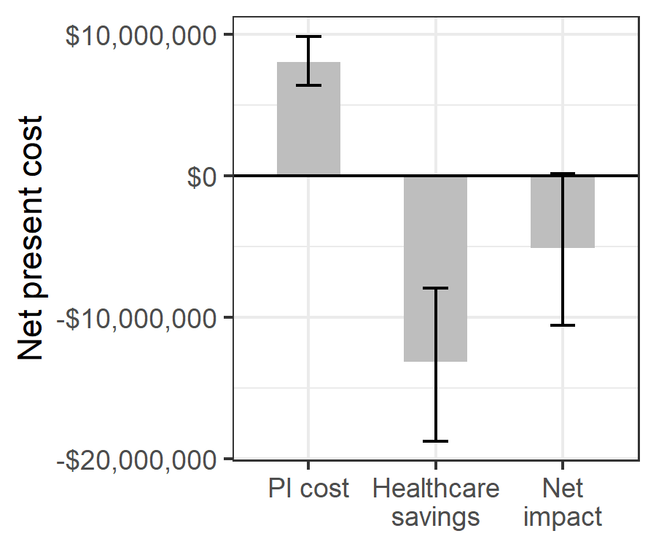

**Fig. 1.** Estimated net impact on healthcare spending of whole blood pathogen inactivation. Net impact is the cost of pathogen inactivation minus the net present healthcare savings from avert transfusion-related adverse events.

##### 

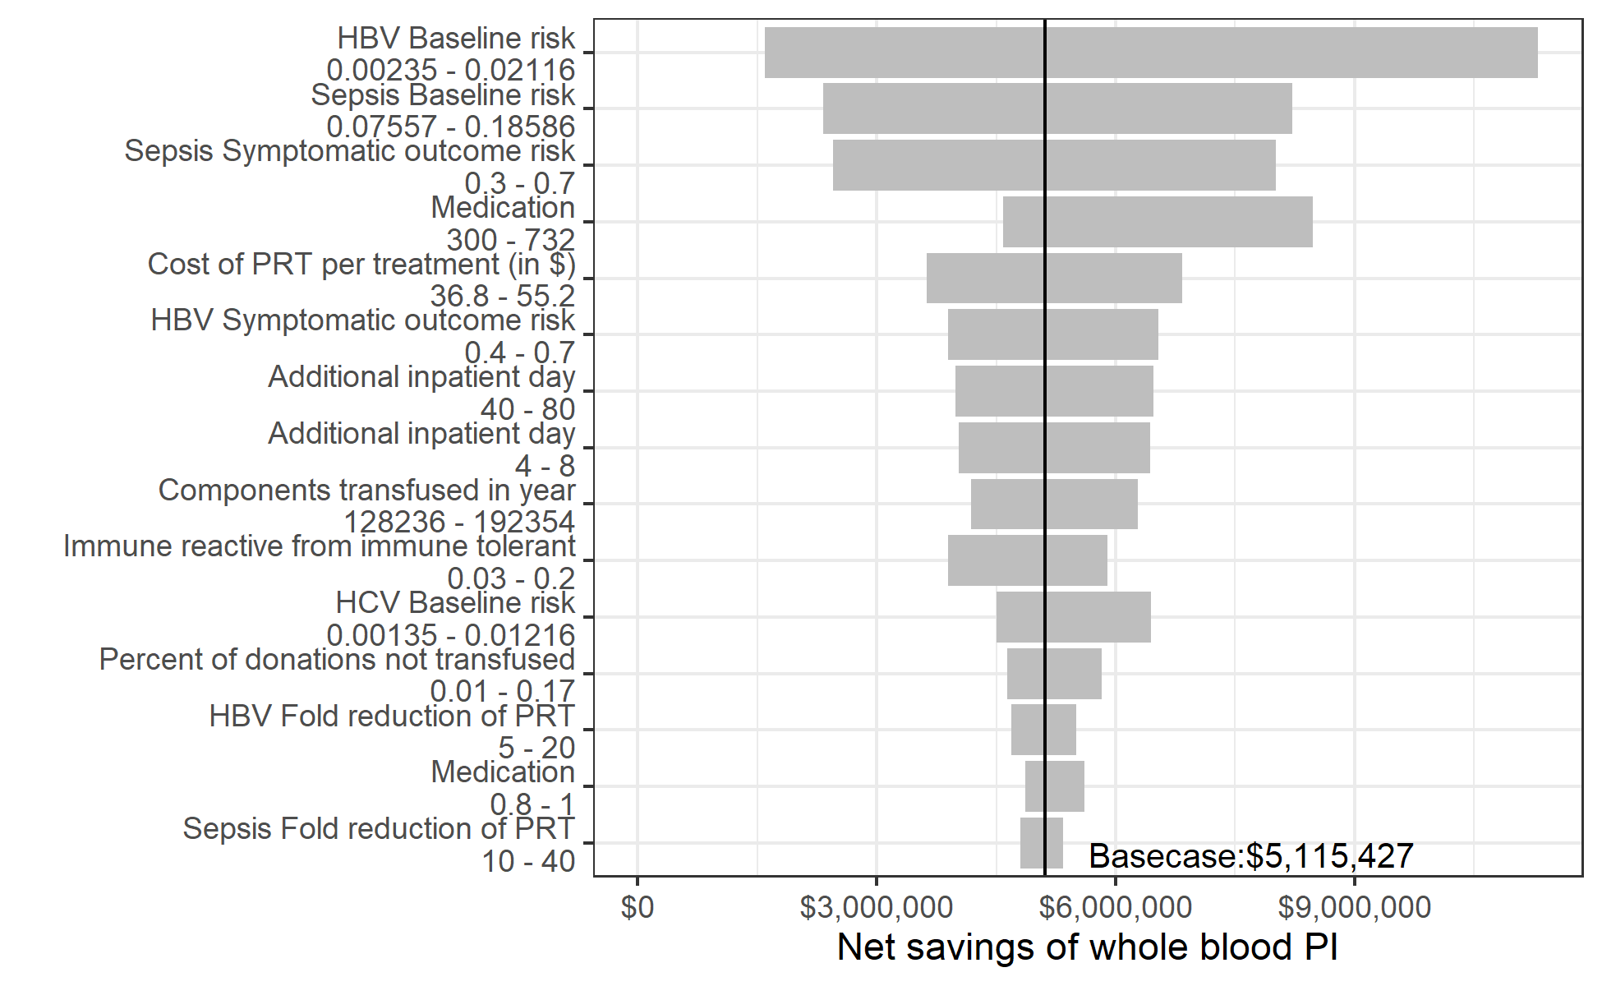

**Fig. 2.** Sensitivity of the net savings of pathogen inactivation to changes in the value of individual input parameters within prespecified uncertainty ranges. Y-axis shows all model parameters for which varying the value along the indicated range while keeping other parameters at their base case value led to a variation of more than $500,000 in the estimated net savings of whole blood pathogen inactivation.

##### 

# Supplemental materials

# A. Calculations for estimating the outcomes of pathogen inactivation

##### 

**Table S1** Parameters for the microcosting calculations

| **Microcosting parameters** | **Value (range); distribution** | **Source** |
| --- | --- | --- |
| Costs | | |
| Additional inpatient day | 60 (40–80); PERT | E |
| Liver function test | 13 (11–15); PERT | E |
| International normalized ratio test | 7.7 (6.3–9); PERT | E |
| Full blood count | 6.4 (5.5–7.3); PERT | E |
| Blood urea nitrogen, creatinine, & electrolytes | 11.5 (10–13); PERT | E |
| Alpha fetoprotein | 11.5 (11–12); PERT | E |
| Breif outpatient visit | 6 (4–8); PERT | E |
| Extensive outpatient visit | 12 (8–16); PERT | E |
| Abdominal ultrasonography | 10 (8–12); PERT | E |
| Endoscopy with band ligation | 271.5 (245–350); PERT | E |
| Spironolactone | 350 (182.5–782); PERT | E |
| Furosemide | 60.8 (55–66); PERT | E |
| Transarterial chemoembolization | 1811 (1400–2200); PERT | E |
| Triphasic CT scan | 173 (150–196); PERT | E |
| Sorafenib (9-12 tablets) | 1916.5 (1643–2190); PERT | E |
| Medication, Sepsis | 372 (300–732); PERT | E |
| Outpatient clinic visit, Malaria | 15 (10–20); PERT | E |
| RDT + Microscopy, Malaria | 3 (1–5); PERT | E |
| Medication, Malaria | 12 (4–20); PERT | E |
| Diagnosis, Syphilis | 15 (10–40); PERT | E |
| Treatment, Syphilis | 12 (5–20); PERT | E |
| Consultation and medication, FNHTR | 25 (20–30); PERT | E |
| HBsAg test, HBV | 3.78 (2.16–5.4); PERT | E |
| HBV profile test, HBV | 35.1 (21.6–48.6); PERT | E |
| HBV DNA test, HBV | 73.8 (72–75.6); PERT | E |
| ART for non-cirrhotic patients, HBV | 325.93 (260.74–391.12); PERT | E |
| ART with cirrhosis, HBV | 869.14 (325.93–3585.18); PERT | E |
| Ab screen and confirmation, HCV | 9 (7–13); PERT | E |
| RNA test, HCV | 145 (120–170); PERT | E |
| Genotyping , HCV | 163 (140–186); PERT | E |
| Antiviral medication, HCV | 650 (547.5–1087); PERT | E |
| ART for decompensated cirrhosis, HCV | 1634 (1095–2173); PERT | E |
| HIV care no ART, HIV | 66.6616835067422 (33.3308417533711–133.323367013484); PERT | # |
| HIV care first year on ART, HIV | 186.7 (149.36–224.04); PERT | # |
| HIV care second year on ART, HIV | 64.5217950644179 (51.6174360515343–77.4261540773015); PERT | # |
| HIV care third year on ART, HIV | 57.0151278969312 (45.6121023175449–68.4181534763174); PERT | # |
| HIV care annual cost after third year on ART, HIV | 46.353617173121 (37.0828937384968–55.6243406077451); PERT | # |
| Proportion receiving | | |
| Medication, Sepsis | 90% (80%–100%); PERT | E |
| Additional inpatient day, Malaria | 5% (1%–9%); PERT | E |
| Outpatient clinic visit, Malaria | 50% (40%–60%); PERT | E |
| Diagnosis & treatment, Syphilis | 10% (5%–20%); PERT | E |
| Additional inpatient day, FNHTR | 50% (40%–60%); PERT | E |
| Quantity received | | |
| Additional inpatient day, Sepsis | 6 (4–8); PERT | E |
| Additional inpatient day, Malaria | 1.5 (1–2); PERT | E |
| Outpatient clinic visit, Malaria | 1.2 (1–2); PERT | E |
| Additional inpatient day, FNHTR | 2 (1–3); PERT | E |
| Annual brief outpatient visits for chronic HBeAg-negative infection no ART, HBV | 3 (2–4); PERT | E |
| Annual brief outpatient visits for chronic HBeAg-negative infection with ART, HBV | 1 (0–2); PERT | E |
| Annual brief outpatient visits for compensated cirrhosis no ART, HBV | 3 (2–4); PERT | E |
| Annual brief outpatient visits for compensated cirrhosis with ART, HBV | 3 (2–4); PERT | E |
| Annual brief outpatient visits for decompensated cirrhosis no ART, HBV | 4 (2–6); PERT | E |
| Annual brief outpatient visits for decompensated cirrhosis with ART, HBV | 4 (2–6); PERT | E |
| Annual brief outpatient visits for acute infection with ART, HCV | 3 (2–4); PERT | E |
| Annual brief outpatient visits for chronic HCV without cirrhosis no ART, HCV | 3 (2–4); PERT | E |
| Annual brief outpatient visits for compensated cirrhosis no ART, HCV | 4 (2–6); PERT | E |
| Annual brief outpatient visits with decompensated cirrhosis no ART, HCV | 4 (2–6); PERT | E |

.

##### 

**Table S2** Annual transition probabilities used in the Markov models of chronic HIV, HBV, and HCV infections

| **Annual transition probability** | | **Value (range); distribution** | **Source** |
| --- | --- | --- | --- |
| **From** | **To** |
| HBV natural history | | | |
| Acute, subclinical | Immune tolerant | 95% (90%–99%); PERT | # |
| Acute, in treatment | Immune tolerant | 95% (90%–99%); PERT | # |
| Immune tolerant | Immune reactive | 10% (3%–20%); β(5.063, 45.57) | # |
| Hepatocellular carcinoma | 0.3% (0%–0.6%); β(3.985, 1324.35) | # |
| Immune reactive | Chronic infection | 0.5% (0%–5%); β(0.154, 30.69) | # |
| Hepatocellular carcinoma | 0.65% (0.27%–1%); β(12.596, 1925.3) | # |
| Carrier | Chronic infection | 2.68% (1.55%–4.71%); β(11.173, 405.74) | # |
| Hepatocellular carcinoma | 0.065% (0%–0.1%); β(0.057, 94.89) | # |
| No infection | 1% (0.97%–2.26%); β(17.146, 1257.65) | # |
| Chronic infection | Compensated cirrhosis | 4% (1%–5.2%); β(11.173, 300.92) | # |
| Hepatocellular carcinoma | 0.616% (0.27%–1%); β(11.3, 1824.5) | # |
| Compensated cirrhosis | Decompensated cirrhosis | 3.9% (3.2%–4.6%); β(2.848, 70.18) | # |
| Hepatocellular carcinoma | 3.66% (0.8%–8%); β(3.947, 103.88) | # |
| HBV-related death | 3.9% (3.9%–50.7%); β(0.27, 6.66) | # |
| Decompensated cirrhosis | Hepatocellular carcinoma | 3.76% (2.3%–7.1%); β(9.411, 240.88) | # |
| HBV-related death | 31.4% (4.3%–57%); β(3.583, 7.83) | # |
| Hepatocellular carcinoma | HBV-related death | 50% (40%–100%); β(5.056, 5.06) | # |
| HBV treatment effectiveness | | | |
| On ART with compensated cirrhosis | Hepatocellular carcinoma | 0.5% (0%–1%); β(0.747, 149) | # |
| On ART with decompensated cirrhosis | Hepatocellular carcinoma | 1% (0%–4.4%); β(0.808, 80) | # |
| HBV treatment uptake | | | |
| Initiation | Acute, in treatment | 10% (0%–25%); PERT | # |
| Immune reactive | On ART with Immune reactive | 60% (50%–90%); PERT | # |
| Chronic infection | On ART with chronic infection | 60% (50%–90%); PERT | # |
| Compensated cirrhosis | On ART with compensated cirrhosis | 75% (55%–95%); PERT | # |
| Decompensated cirrhosis | On ART with decompensated cirrhosis | 65% (45%–85%); PERT | # |
| HCV natural history | | | |
| Acute, subclinical | No infection | 32% (15%–40%); PERT | # |
| Chronic infection | Compensated cirrhosis | 1.1% (0.5%–1.8%); PERT | # |
| Compensated cirrhosis | Decompensated cirrhosis | 6.4% (3%–7%); PERT | # |
| Hepatocellular carcinoma | 3.6% (1.5%–4%); PERT | # |
| Decompensated cirrhosis | Hepatocellular carcinoma | 6.8% (4.1%–9.9%); PERT | # |
| HCV-related death | 16.8% (12%–40%); PERT | # |
| Hepatocellular carcinoma | HCV-related death | 60.5% (30%–80%); PERT | # |
| HCV treatment effectiveness | | | |
| ART states | No infection | 95% (90%–99%); PERT | # |
| HCV treatment uptake | | | |
| Initiation | Acute, in treatment | 10% (0%–25%); PERT | # |
| Chronic infection | On ART with chronic infection | PERT  10% (5% - 30%) | # |
| Compensated cirrhosis | On ART with compensated cirrhosis | PERT  30% (10% - 40%) | # |
| Decompensated cirrhosis | On ART with decompensated cirrhosis | 70% (50%–90%); PERT | # |
| HIV natural history | | | |
| No ART, 3+ years | AIDS (pediatric) | 4.21% (3.07%–5.62%); PERT | # |
| AIDS (adult) | 15% (10.1%–22.6%); PERT | # |
| HIV-related death (pediatric) | 1.5% (0%–6.9%); PERT | # |
| HIV-related death (adult) | 0% (0%–5.5%); PERT | # |
| AIDS | HIV-related death (pediatric) | 60.2% (32.4%–60.2%); PERT | # |
| HIV-related death (adult) | 61.5% (28.6%–64.9%); PERT | # |
| HIV treatment uptake | | | |
| No ART, 1st year | On ART | 60% (30%–90%); PERT | # |
| No ART, 2nd year | On ART | 60% (30%–90%); PERT | # |
| No ART, 3+ years | On ART | 60% (30%–90%); PERT | # |

##### 

**Table S3** Calculations used for each disease state (acute illness for sepsis, malaria, febrile non-hemolytic transfusion reactions, and syphilis; annual costs for each disease state in the HBV and HIV Markov models)

| **Disease state** | **Microcosting calculation** |
| --- | --- |
| Sepsis | (cost × quantity) additional inpatient days +  (proportion × cost) medication |
| Malaria | (cost × quantity × proportion) additional inpatient days +  (cost × quantity × proportion) outpatient clinic visits +  (cost) diagnosis +  (cost) medication |
| FNHTR | (cost) medication and consult +  (cost × quantity × proportion) additional inpatient days |
| Syphilis | (cost × proportion) diagnosis +  (cost × proportion) medications |
| HBV acute clinical | (2 × cost) HBsAg test +  (cost) HBV profile +  (cost) HBV DNA test +  (cost) extensive outpatient clinic visit +  (cost) brief outpatient clinic visit |
| HBV acute subclinical | 0 |
| Immune tolerant subclinical | 0 |
| Immune reactive subclinical | 0 |
| HBV immune tolerant | (cost) extensive outpatient clinic visit +  (cost) HBsAg test +  (cost) HBV profile +  (cost) HBV DNA test +  (cost) liver function test |
| HBV carrier | 0 |
| HBV immune reactive | (cost) extensive outpatient clinic visit +  (cost) HBsAg test +  (cost) HBV profile +  (cost) HBV DNA test +  (cost) liver function test |
| HBV chronic HBeAg- subclinical | 0 |
| HBV chronic HBeAg- Monitoring | (cost) liver function test +  (cost) HBV profile +  (cost) HBV DNA test +  (cost) blood urea nitrogen, creatinine, & electrolytes +  (cost) full blood count +  (cost) alpha fetoprotein test +  (cost) abdominal ultrasonography +  (cost × quantity) brief outpatient visit |
| HBV compensated cirrhosis | (cost) liver function test +  (cost) international normalized ratio test +  (2 × cost) HBV DNA test +  (cost) blood urea nitrogen, creatinine, & electrolytes +  (cost) full blood count +  (2 × cost) alpha fetoprotein test +  (2 × cost) abdominal ultrasonography +  (cost × quantity) brief outpatient visit |
| HBV decompensated cirrhosis | (cost) liver function test +  (cost) international normalized ratio test +  (2 × cost) HBV DNA test +  (cost) Blood urea nitrogen, creatinine, & electrolytes +  (cost) Full blood count +  (2 × cost) alpha fetoprotein test +  (2 × cost) abdominal ultrasonography +  (2 × cost) endoscopy with band ligation +  (cost) spironolactone +  (cost) furosemide +  (cost × quantity) brief outpatient visit |
| HBV hepatocellular carcinoma | (cost) liver function test +  (cost) international normalized ratio test +  (cost) Full blood count +  (cost) alpha fetoprotein test +  (cost) triphasic CT scan +  (cost) endoscopy with band ligation +  (cost) sorafenib +  (cost) transarterial chemoembolization |
| HBV no infection | 0 |
| HBV on ART immune reactive | cost) extensive outpatient clinic visit +  (cost) HBsAg test +  (cost) HBV profile +  (cost) HBV DNA test +  (cost) liver function test +  (cost) HBV antivirals for non-cirrhotic patients |
| HBV on ART chronic HBeAg- | (cost) liver function test +  (cost) HBV profile +  (cost) HBV DNA test +  (cost) blood urea nitrogen, creatinine, & electrolytes +  (cost) full blood count +  (cost) alpha fetoprotein test +  (cost) abdominal ultrasonography +  (cost × quantity) brief outpatient visit +  (cost) HBV antivirals for non-cirrhotic patients |
| HBV on ART compensated cirrhosis | (cost) liver function test +  (cost) international normalized ratio test +  (2 × cost) HBV DNA test +  (cost) blood urea nitrogen, creatinine, & electrolytes +  (cost) full blood count +  (2 × cost) alpha fetoprotein test +  (2 × cost) abdominal ultrasonography +  (cost × quantity) brief outpatient visit |
| HBV on ART decompensated cirrhosis | (cost) liver function test +  (cost) international normalized ratio test +  (2 × cost) HBV DNA test +  (cost) blood urea nitrogen, creatinine, & electrolytes +  (cost) full blood count +  (2 × cost) alpha fetoprotein test +  (2 × cost) abdominal ultrasonography +  (cost × quantity) brief outpatient visit +  (cost) HBV antivirals for patients with cirrhosis |
| HBV related death or other-cause death | 0 |
| HCV acute subclinical | 0 |
| HCV acute with ART | (cost) Ab screen and confirmation +  (2 × cost) HCV RNA test +  (cost) HCV genotyping +  (cost) liver function test +  (cost) Blood urea nitrogen, creatinine, & electrolytes +  (cost × quantity) brief outpatient visit +  (cost) HCV antivirals |
| HCV no infection | 0 |
| HCV chronic subclinical | 0 |
| HCV chronic with ART | (cost) liver function test +  (cost) Blood urea nitrogen, creatinine, & electrolytes +  (cost) Full blood count +  (cost) alpha fetoprotein test +  (cost) abdominal ultrasonography +  (cost) HCV genotyping +  (2 × cost) HCV RNA test +  (cost × quantity) brief outpatient visit (cost) HCV antivirals |
| HCV compensated cirrhosis | 0 |
| HCV compensated cirrhosis with ART | **(cost) liver function test +  (cost) international normalized ratio test +  (cost) Blood urea nitrogen, creatinine, & electrolytes +  (cost) Full blood count +  (2 × cost) alpha fetoprotein test +  (2 × cost) abdominal ultrasonography +  (cost) HCV genotyping +  (2 × cost) HCV RNA test +  (cost × quantity) brief outpatient visit** |
| HCV decompensated cirrhosis | 0 |
| HCV decompensated cirrhosis with ART | (cost) liver function test +  (cost) international normalized ratio test +  (cost) Blood urea nitrogen, creatinine, & electrolytes +  (cost) Full blood count +  (2 × cost) alpha fetoprotein test +  (2 × cost) abdominal ultrasonography +  (cost) HCV genotyping +  (3 × cost) HCV RNA test +  (2 × cost) endoscopy with band ligation +  (cost) spironolactone +  (cost) furosemide +  (cost × quantity) brief outpatient visit (cost) HCV antivirals |
| HCV hepatocellular carcinoma | (cost) liver function test +  (cost) international normalized ratio test +  (cost) Full blood count +  (cost) alpha fetoprotein test +  (cost) triphasic CT scan +  (cost) endoscopy with band ligation +  (cost) sorafenib +  (cost) transarterial chemoembolization |
| HCV related death or other-cause death | 0 |

##### 

**Table S4** Calculated annual costs for each disease state in the HIV, HBV, and HCV disease progression Markov models

To do.

##### 

**Fig. S1.** Schematics for Markov models used to estimate net-present lifetime costs for HIV, HBV, and HCV.

##### 

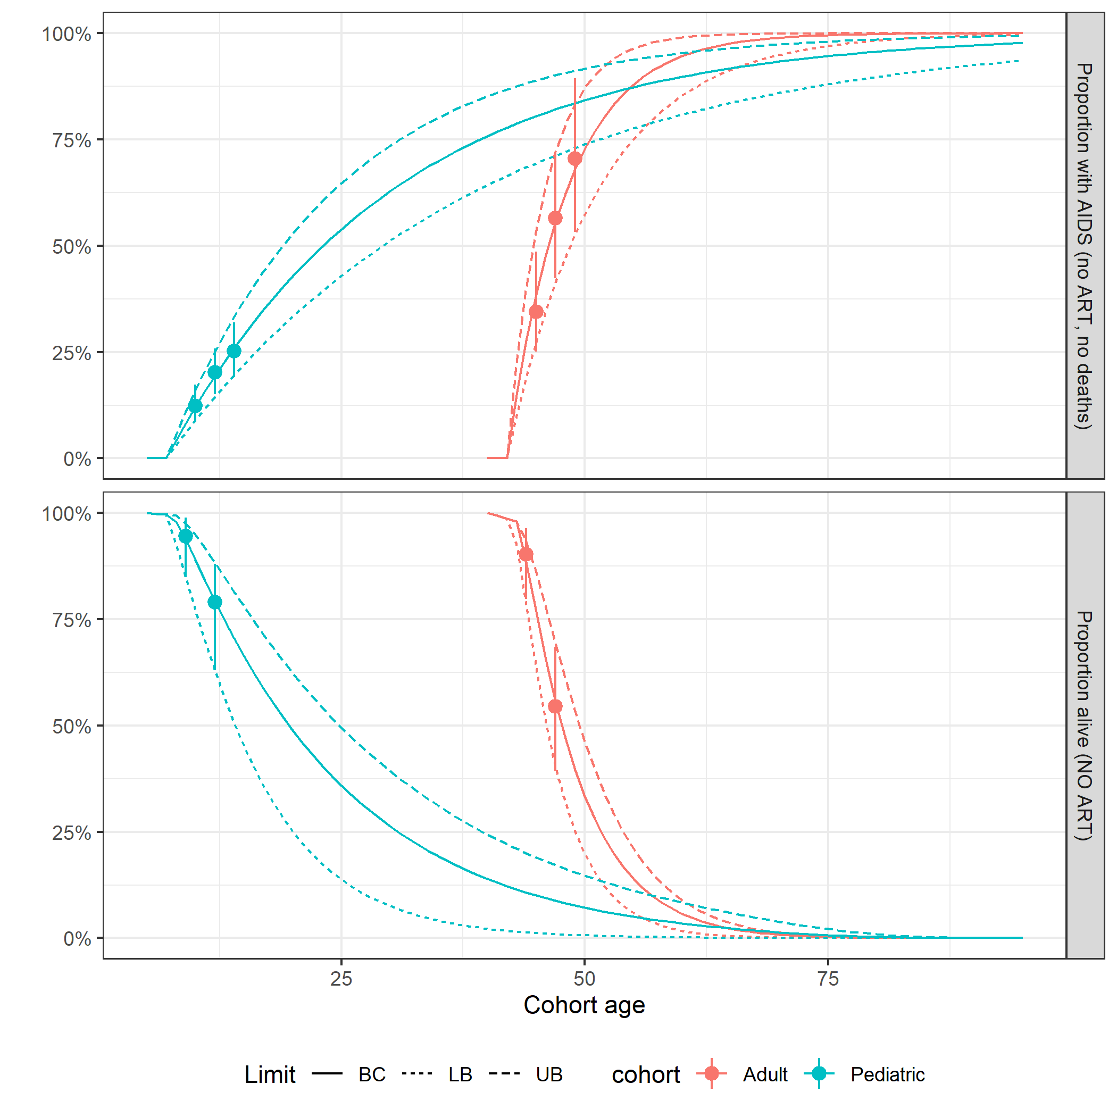

**Fig. S2.** Calibration plots for HIV transition probabilities.

##### 

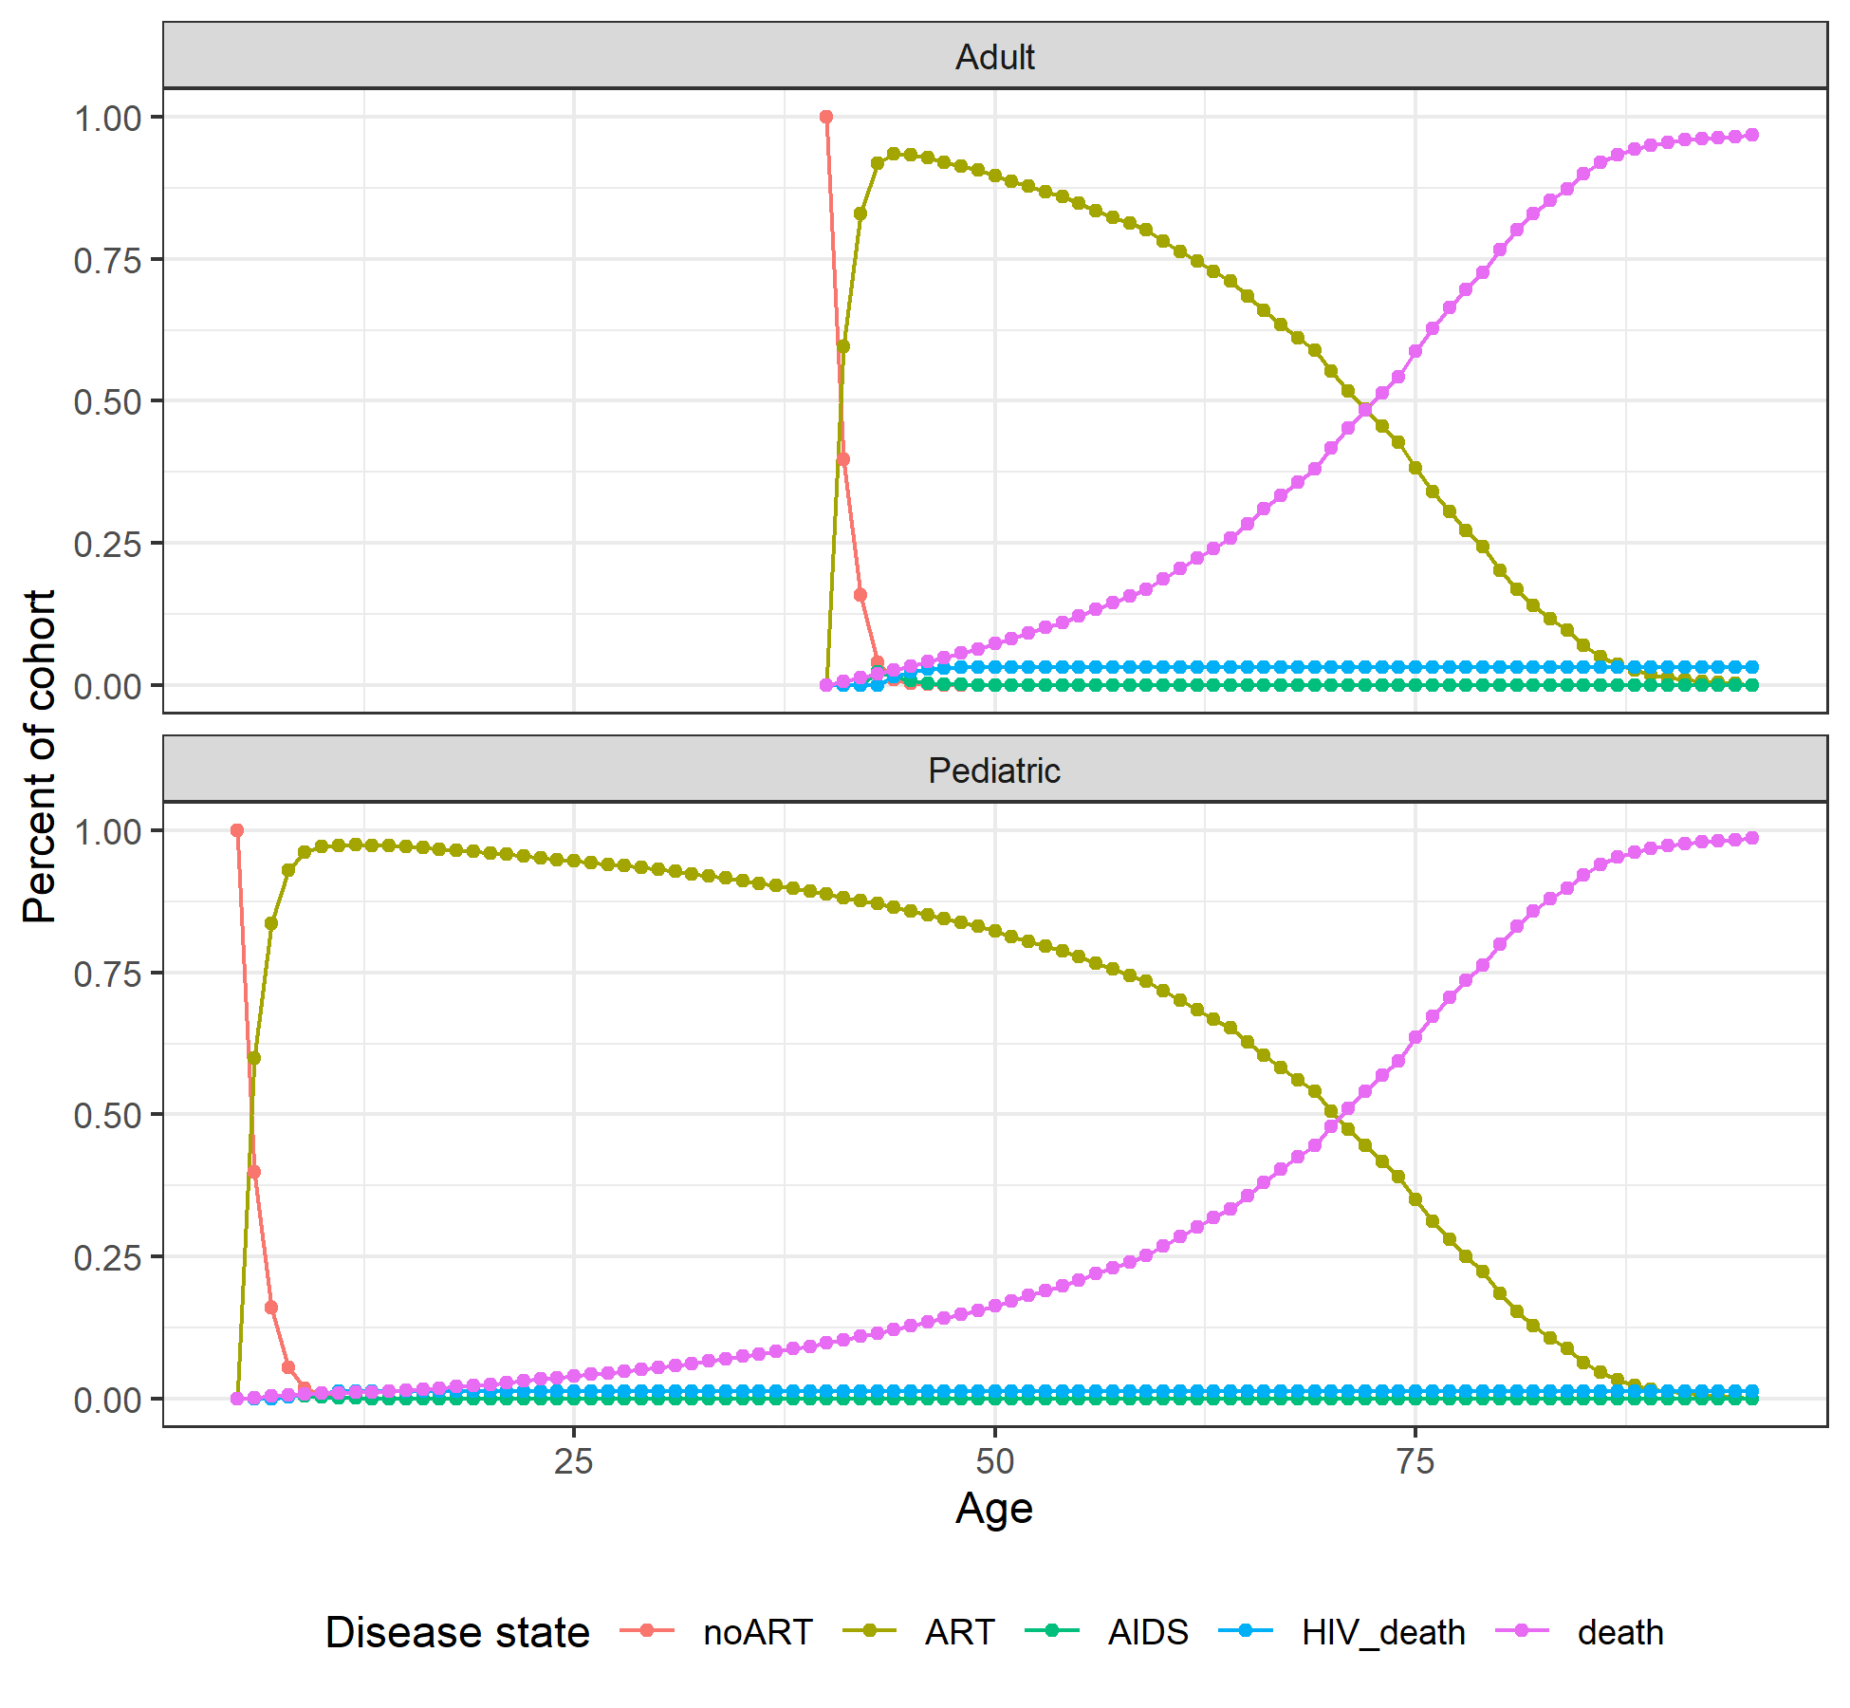

**Fig. S3.** Markov trace plot for HIV pediatric and adult cohorts.

##### 

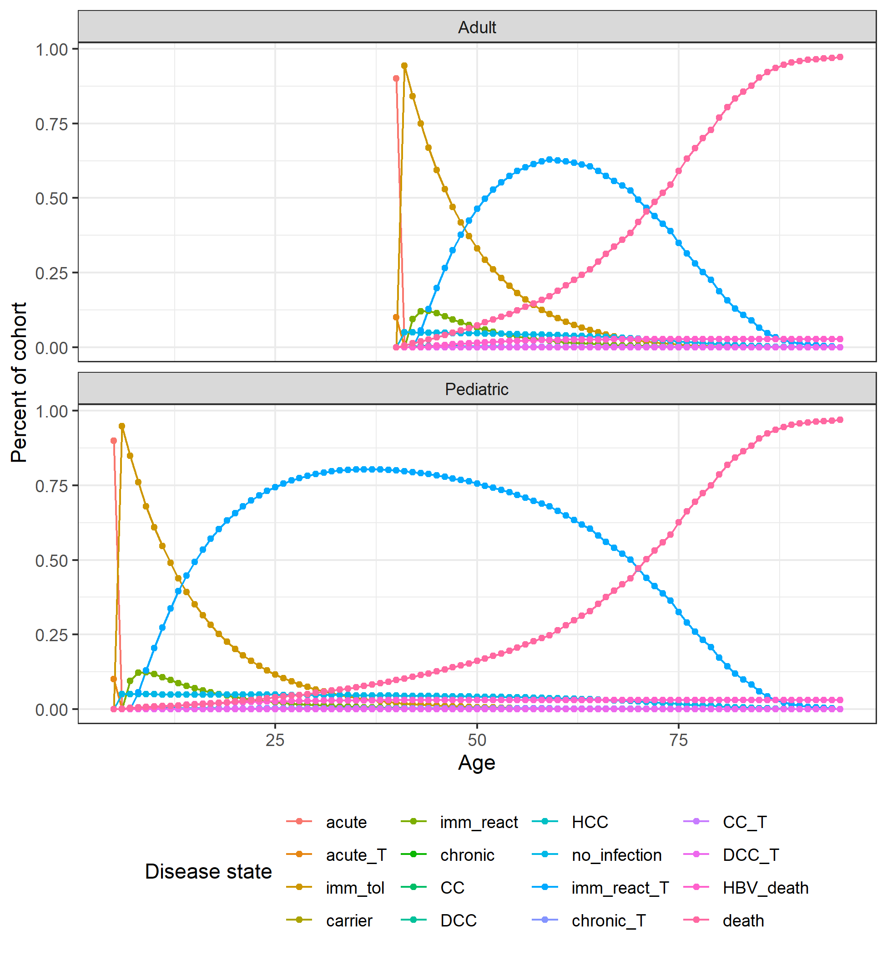

**Fig. S4.** Markov trace plot for HBV pediatric and adult cohorts.

##### 

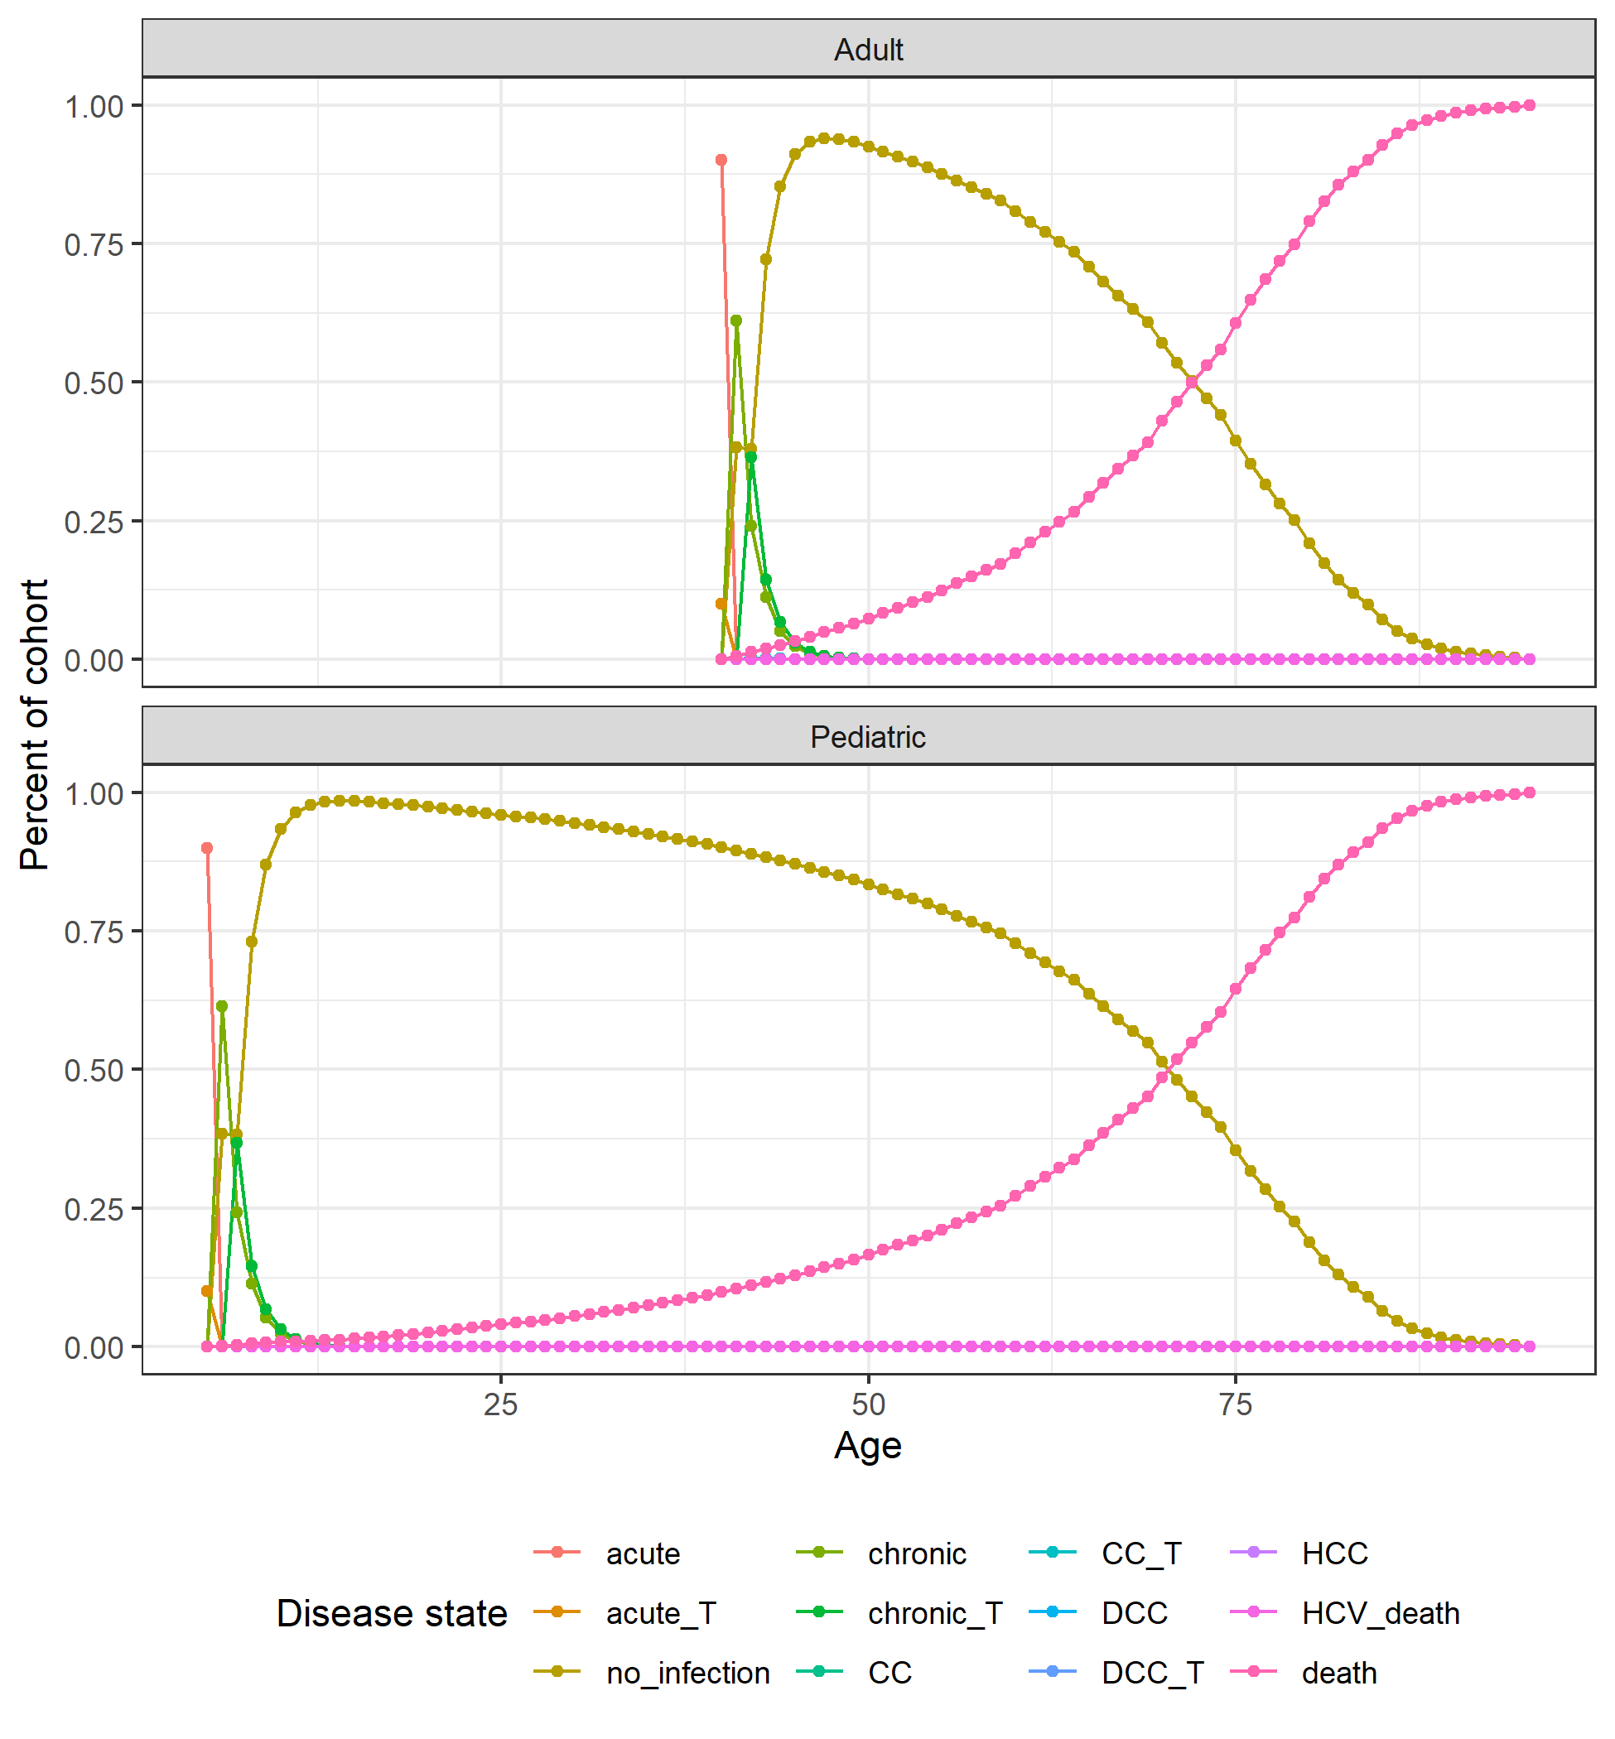

**Fig. S5.** Markov trace plot for HCV pediatric and adult cohorts.